# Inventory – 10/5/2014

|  |  |  |  |  |
| --- | --- | --- | --- | --- |
| Avionics Inventory 10/5/2014 | | | | |
| Component | Inventory | Number to Purchase | Cost per unit | Total Cost |
| eLogger V4 | 2 | 2 | $70 | $140 |
| Altimeter V4 | 3 | 1 | $38 | $38 |
| Airspeed V3 | 4 | 0 | $43 | $0 |
| pitot tube | 4 | 0 | $10 | $0 |
| GPS V4 | 4 | 0 | $80 | $0 |
|  |  |  |  | $178 |
|  |  |  |  |  |
| Addition Inventory | | | | |
| eLogger V3 | 1 |  |  |  |

Avionics inventory was taken on 10/6/2014 - the results can be found in the table above. Each item listed above was tested for working condition. Some results from this testing can be found in the remainder of this report.

There are currently 4 teams in AAE 451. As such, it is our recommendation that there be atleast 4 of each component from the table above in avionics inventory. To meet this requirement, we recommend for the purchase of 2 eLogger V4 units as well as an Altimeter V4 unit.

From the table, also note that avionics inventory also includes an eLogger V3. However, this hardware doesn’t have a USB port and requires the use of a specialized USB cable that could not be located in inventory. As such, this logger cannot currently be used.

# Altimeter Testing

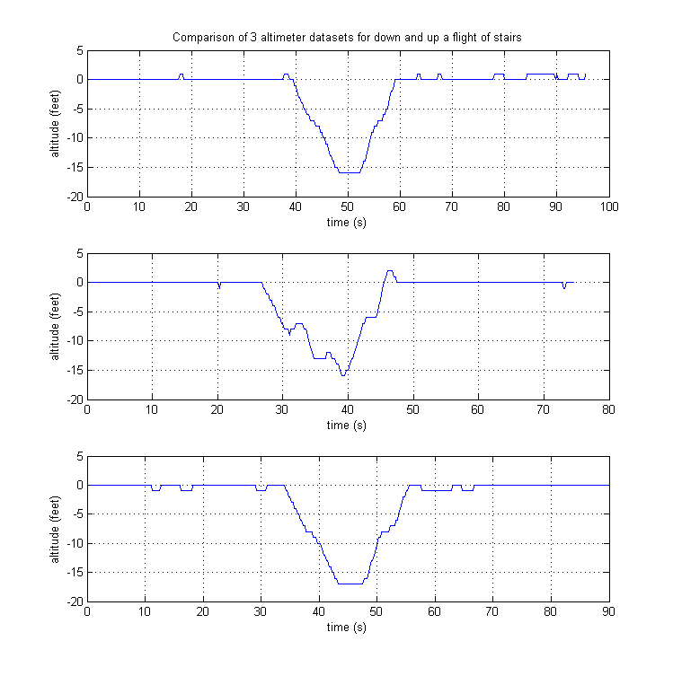

Testing procedure:

1. Connect altimeter to elogger
2. Power elogger with external battery
3. Walk from 2nd story ARMS build lab to 1st floor atrium and back.

Each altimeter was tested with this procedure, each dataset can be seen in the figure above. Please note that upon initialization, the altitude is referenced to zero.

# GPS/Altimeter Testing

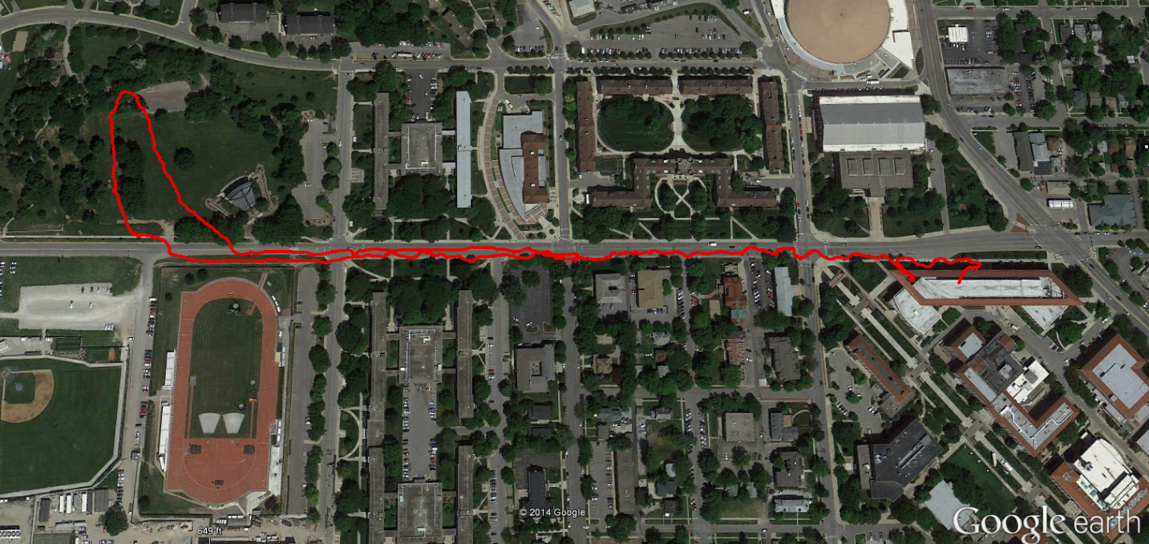

Testing procedure:

1. Connect GPS to elogger
2. Connect Altimeter to elogger
3. Power elogger with external battery
4. Conduct walkabout:
   1. Start in 2nd story ARMS build lab
   2. Walk to the top of the hill across from Purdue Gold fields
   3. Walk back to ARMS lab

Only 1 GPS was tested with this procedure. 2 altimeters were tested with this procedure.

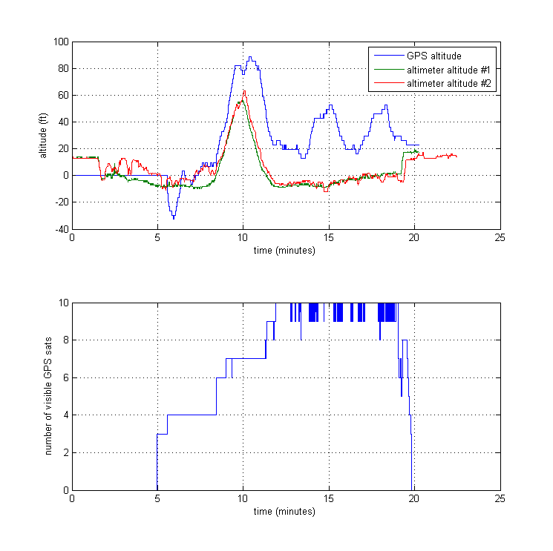

Erroneous GPS data

Top of hill

Lose GPS data

Acquire GPS data

The above figure compares GPS altitude data with barometric altitude (altimeter) data. We see that the 2 altimeter dataset agree fairly well. These dataset illustrate how the test begins and ends in the 2nd story ARMS build lab 🡪 14 feet above ground level.

The GPS altitude displays some erroneous data during the walk back to Armstrong. Additionally, the GPS altitude appears to overshoot the actual altitude.

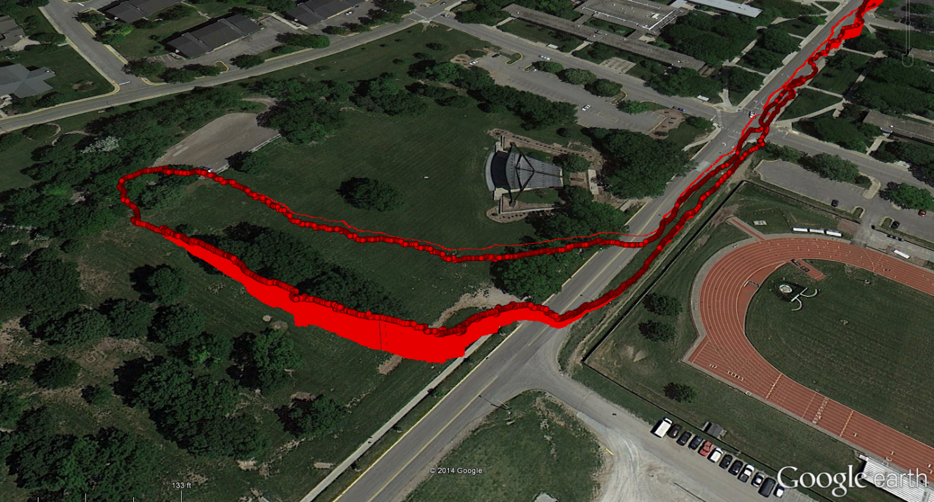

Elevation disagreement between recorded GPS data and Google Earth data

Hill Descent

Hill Ascent

Google Earth has fairly accurate topographical knowledge of West Lafayette. As such, we are able to plot the 3-d trajectory and visualize the accuracy of the GPS altitude.

From the previous figure, we saw that the GPS altitude was higher than the altimeter reported altitude during descent from the hill. Google Earth corroborates with observation. We see that GPS altitude is higher than the Google earth ground-elevation during descent from the hill.